exchange rate determination

“Having endeavored to forecast exchange rates for more than half a century, I have understandably developed significant humility about my ability in this area…”
- Alan Greenspan

Figure 1: Exchange Rate Determination
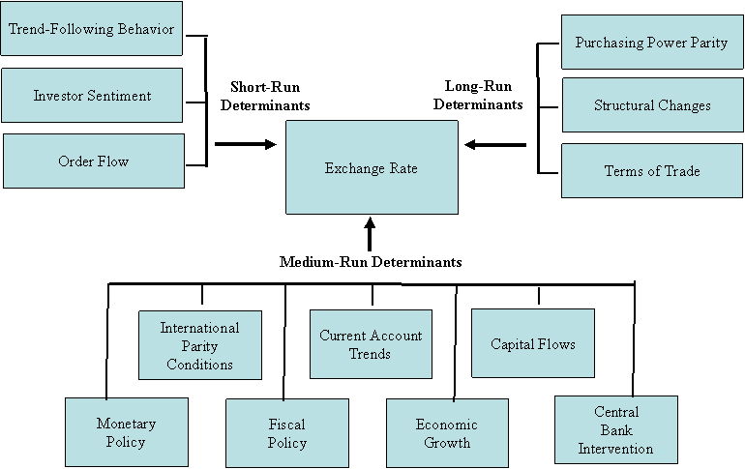
Source: Exchange Rate Determination

I. Short-Run Forecasting Tools

Short-term changes in exchange rates are the most difficult to predict and are often determined based on bandwagon effects, overreaction to news, speculation, and technical analysis.

Trend-Following Behavior is the tendency for the market to follow a trend. In other words an increase in the exchange rate is more likely to be followed by another increase.

Investor Sentiment is based on the consensus of the market. For example if the market is bullish on the dollar, then the dollar is likely to strengthen versus other currencies.

The FX market is quite different from the world equity markets in one important aspect: transparency. In equity markets, rules ensure that volume and price data are readily available to all parties… this is NOT the case in FX markets. In fact large FX dealers are able to observe factors such as: shifts in risk appetite, liquidity needs, hedging demands, and institutional rebalancing.

Order Flow - there is evidence of a positive correlation between spot exchange rate movements and order flows in the inter-dealer market and with movements in customer order flows.

Three explanations for the cause of these correlations have been put forth: 1) Private information - related to the payoff from holding the currency may be contained in the order flow data. For example, future interest rates or the discount rate may be known to traders. 2) Liquidity effects – dealers charge a temporary risk premium to absorb unwanted inventory. 3) Feedback trading – the positive correlation could be related to customers buying a currency that has just appreciated (or vice versa).

II. Long-Run Forecasting Tools

Purchasing Power Parity (PPP) states that since the prices should be the same across countries, the exchange rate between two countries should be the ratio of the prices in each country.

Relative PPP states that the exchange rate will change to offset differences in national interest rates. In other words, if Country A has higher inflation than Country B, you can expect Country A’s currency to depreciate versus Country B’s currency.

Structural Changes – three structural changes can affect long-term trends in exchange rates: 1) an increase in investment spending, 2) fiscal stimulus, 3) a decline in private savings. It is the net impact of structural changes that determines if the country’s currency will rise or fall.

- Investment spending – domestic investment in a country will help to strengthen a country’s currency. For example, the United States experienced an investment boom in the 1990s.
- Fiscal stimulus – government investment in a country can also help strengthen a country’s currency. For example, Turkey has enjoyed fiscal stimulus and government spending in recent years.
- Private savings – the citizens of a country’s tendency to save will help strengthen a country’s currency. For example, Japan has had a large and persistent current-account surplus that has led to a stronger currency.

Terms of Trade – is the idea that the price of a good that trades in international markets will have an impact of the associated country’s currency. This can work in terms of both imports and exports. For example, in countries where commodities make up a large portion of GDP, like Australia, Canada, and New Zealand, there is a strong positive relationship between the price of commodities and the strength of the associated country’s currency. On the other hand, in Europe, the higher prices for oil, have led to a weaker currency.

III. Medium-Run Forecasting Tools

International Parity Conditions – the key international parity conditions are 1) purchasing power parity, 2) covered interest-rate parity, 3) uncovered interest-rate parity, 4) the Fisher effect, and 5) forward exchange rates.

Figure 2: International Parity Conditions
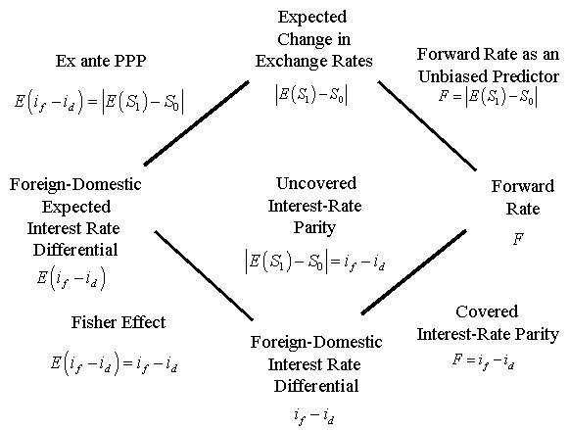
Source: Exchange Rate Determination

- Purchasing power parity – states that since the prices should be the same across countries, the exchange rate between two countries should be the ratio of the prices in each country.

Example: If a hamburger is $2.54 in the United States and 3.60 real (R$) in Brazil, then the PPP spot rate should be:

If the actual exchange rate is, then according to the PPP theory the Brazilian real is undervalued by 35%.
FYI McDonalds' Big Mac is produced locally in almost 120 countries!

- Covered interest-rate parity –the idea that an imbalance in parity conditions can create a “risk less” opportunity for an arbitrager.

Exhibit 6.7 Covered Interest Arbitrage (CIA)

Example:
Step 1: Convert $1,000,000 at the spot rate of ¥106.00/$ to ¥106,000,000
Step 2: Invest the proceeds, (¥106,000,000), in a euroyen account for six months, earning 4% per annum, or 2% for 180 days.
Step 3: Simultaneously sell the future yen proceeds (¥108,120,000) forward for dollars at the 180-day forward rate of ¥103.50/$. Note: at this point you have “locked in” the amount of $1,044,638 in 180 days (or 6 months).
Step 4: Out of the $1,044,638 you have to repay the loan (plus interest), this is called your opportunity cost of capital. To do this, calculate the interest rate for the period (8% per year is 4% for 180 days). So to borrow $1,000,000 you have to pay $40,000 in interest at the end of 6 months. Subtract the $1,040,000 from the $1,044,638 that you will receive from your forward contract for a “risk less” profit of $4,638.

Notice that these activities should help the currencies return to equilibrium.

- Uncovered interest-rate parity - Uncovered interest arbitrage is great when you are dealing with fixed exchange currencies, because the profit at the end of the period is dependant of the exchange rate (and since this is “uncovered” it is a very risky investment).

Exhibit 6.7 Uncovered Interest Arbitrage
Note: there is a typo in the book. The correct figures are:

$83,333.33
and
$87,500.00

Since there are men and women making a killing in this business, the opportunities for smaller investors are almost impossible… It is these two types of arbitrage that keep exchange rates more or less in equilibrium.

- Fisher effect - the nominal interest rate (i) in a country should be equal to the real rate of interest (r) plus expected inflation (π).

i = r + π

- Forward exchange rates – an exchange rate quoted today for settlement at a future date.

Forward rates are unbiased predictors of future exchange rates. An unbiased predictor means that “on average” the estimation will be wrong on the up side or the downside with equal frequency and degree. In other words, the errors are normally distributed.

Current Account Trends – Countries that run persistent current-account surpluses will see their currencies appreciate over time. Current account imbalances are driven by structural changes in international competitiveness, changes in the terms of trade, and long-term shifts in national savings-investment.

In terms of the current account three channels influence the exchange rate: 1) the supply and demand for foreign exchange, 2) the transfer of wealth from deficit to surplus countries, and 3) the sustainability of external debt.

- Supply and demand – the supply of dollars is driven by the U.S. demand for foreign goods and services and the demand for dollars is driven by foreign demand for U.S. goods and services.
- Wealth transfer – shifts in wealth from deficit to surplus nations can lead to shifts in global asset preferences.
- Sustainability of external debt – deficits will lead to a depreciation of the deficit country’s currency.

The United States has a sizable current-account deficit, one policy to reduce this deficit could be to encourage domestic savings through a tighter U.S. fiscal policy stance. “It is unlikely that an efficient forward-looking market would be willing to finance an unending string of current account deficits until the deficit became hopelessly engulfed in a debt trap.”

Capital Flows – foreign demand for a country’s currency will lead to an increase in the value of the domestic currency. Capital flows can come from foreign direct investment (FDI), a flight to quality, perceived strength, or the existence of investment opportunities.

Monetary Policy – expansionary monetary policy will lead to a depreciation of the domestic currency, because lower interest rates will generate an outflow of capital.

In the Mundell-Flemming model, an expansionary fiscal polity typically helps raise domestic interest rates and increases domestic economic activity. Increased domestic interest rates should increase capital inflow, which can 1) increase the currency’s value BUT increased domestic economic activity can contribute to a deterioration of the trade account and 2) decrease the currency’s value. (See Figure 3)

Figure 3: Mundell-Flemming Model
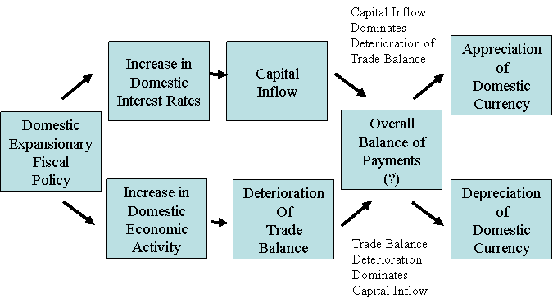
Source: Exchange Rate Determination

Tight monetary policy in Japan in the early 1990s contributed to a major strengthening of the yen.

According to Mishkin (1996) there are five channels of monetary policy 1) the interest rate channel, 2) the bank lending channel, 3) the exchange rate channel, 4) the inflation expectations channel, and 5) the wealth effect channel.

- Interest rate channel – easier monetary policy will lead to lower short-term interest rates and investment spending will rise.
- Bank lending channel – expansionary monetary policy will lead to increased bank loans and investment spending will rise.
- Exchange rate channel – easy monetary policy will lead to a depreciation of the exchange rate which will contribute to a rise in net exports.
- Inflation expectations – a higher expected inflation rate will lower the real short-term interest rate.
- Wealth effect channel – easier monetary policy will raise equity prices and real estate values with will increase net wealth and boost consumption.

Fiscal Policy – an expansionary fiscal policy raises domestic interest rates and increases domestic economic activity.

Economic Growth – in the short run if the economy is growing stronger relative to other economies the increases in economic activity that create attractive investment opportunities will strengthen the currency.

Central Bank Intervention – central banks often participate in foreign exchange markets the argument most often made to justify intervention is that the exchange rate is “simply too important a price to be left to the market.” The assumption is that central bank authorities can do a better job in the markets in terms of driving exchange rates toward their long-term equilibrium values.

There are several arguments made for central bank intervention: 1) foreign exchange markets may fail to use all information, 2) foreign exchange markets may be dominated by trend-following traders, 3) excessive speculation, 4) excessive risk aversion, 5) foreign exchange markets may be using an incorrect model of exchange-rate determination, 6) market perceptions may be flawed, 7) foreign exchange markets may be pre-occupied with extraneous information, 8) foreign exchange markets may be subject to persistent mood swings.

Central banks intervene in foreign exchange markets through direct and indirect channels. Direct channels include: 1) central banks alter the flow of supply of foreign exchange relative to the demand for foreign exchange, 2) alter the supply of money relative to private sector’s demand for money, and 3) alter the supply of domestic bonds relative to the supply of foreign bonds. Indirect channels include: 1) to signal monetary-policy intentions, 2) to signal that an exchange rate is deviating too far from its long-run equilibrium value (i.e. to anchor market expectations) and 3) to take advantage of the element of surprise and intervene when exchange rates have overshot their equilibrium level.

IV. Final Comments

Strong Dollar

The official attitude of the dollar in the United States has swung from neglect, to active encouragement of a weaker dollar, to active intervention to stop the dollar from falling, and most recently to acknowledge that a strong dollar is in the U.S. national interest. But not everyone in the U.S. feels that a strong dollar is goof for the economy.

The Honorable Paul O’Neill
Secretary of the Treasury
Washington DC 20220
June 4, 2001
Dear Mr. Secretary:

We are writing to tell you that at current levels the exchange value of the dollar is having a strong negative impact on manufacturing exports, production, and employment. A growing number of American factory workers are now being laid off principally because the dollar is pricing our products out of markets – both at home and abroad. Small firms are being affected as well as large ones. As you balance your responsibilities for international monetary stability and domestic economic growth, we ask that you take into account the growing burden an overvalued dollar is imposing on U.S. manufacturing.

Since early 1997 the dollar has appreciated by 27 percent. Industries such as aircraft, automobiles and parts, paper and forest products, machine tools, medical equipment, steel, and other capital goods-as well as consumer goods producers-are being affected very significantly. No amount of cost cutting can offset a nearly 30 percent dollar markup.

The total effect on the U.S. economy is staggering. These output losses are particularly serious at this time, as they coincide with a general economic slowdown. The economic fundamentals have changed dramatically in the last six months. Production and profitability are down, and manufacturing employment has fallen by more than a half million jobs since mid-2000. Yet, in the face of slowing economic growth, declining interest rates, and rising manufacturing unemployment, the dollar has remained high.

In our view, a clarification of Treasury policy is in order, to be certain that it is not seen as endorsing an ever stronger solar irrespective of the economic fundamentals. We urge the Treasury to make it clear that the value of the dollar should be consistent with economic reality and market conditions. This policy should be buttressed by a commitment to further reductions in interest rates and to cooperating in exchange markets as appropriate. Moreover, it is vital that the Treasury not condone currency manipulation by trading partners seeking to make their exports more competitive.

Mr. Secretary, 18 million workers and their families depend directly on the continued strength and competitiveness of American manufacturing. Many more Americans rely on stockholding in our companies for their retirement income. We would like to meet with you to describe more fully the effects the value of the dollar is having on us. We hope you will be able to accommodate our request.

Respectfully,

Jerry J. Jasinowski, President John W. Douglas, President and CEO
National Association of Manufacturers Aerospace Industries Association

W. Henson Moore, President and CEO Don Carlson, President
American Forrest and Paper Association The Association for Manufacturing Technology

Stephen Collins, President Christopher M. Bates, President & CEO
Automotive Trade Policy Council Motor Equipment Manufacturers Association
The Regan Years

The 1981 Economic Recovery Tax Act implemented by U.S. President Regan included cuts in marginal tax rates for individuals and investment tax credits and accelerated depreciation allowances for corporations to help spur business investment. The business-oriented tax cuts helped boost the dollar’s real long-run equilibrium values because they made the U.S. government more competitive.

Strong Dollar in the late 1990s

The rise in the dollar’s value versus the Euro in the late 1990s can be attributed to the following factors: 1) strong productivity gains in the United States, 2) structural shifts in portfolio flows from Europe to the United States, 3) increased M&A flows from Europe to the United States, 4) structural rigidities in Europe, 5) the New Economy, 6) relative economic growth rates, 7) government policies, 8) risk associated with the Euro-changeover and 9) the U.S. equity market rally.

Hot Money

Excessive capital inflows can contribute to 1) an unwarranted appreciation of the emerging market currency, 2) a huge buildup in external indebtedness, 3) a financial asset or property market bubble, 4) a consumption binge that contributes to an explosive growth in domestic credit and/or the current-account deficit, or 5) overinvestment in risky projects and questionable activities.

Contagion

Contagion is when speculative pressure spreads from one currency to another. Five channels of contagion have been identified: 1) strong bilateral or third-party trade links 2) similar macroeconomic performance, 3) common lenders/creditors, market liquidity, and investor risk appetite, 4) a general decline in global investor preferences, and 5) government policies.

Banking Crises and Currency Crises

Kaminsky and Reinhart (1997) find that banking crises are a good leading indicator of currency crises. Not all crises are preceded by banking crises, but banking crises tend to aggravate the crises. Banking crises in Mexico and Asia are widely cited as accentuating the slide of the currencies.

Figure 4: Banking Crises and Currency Crises

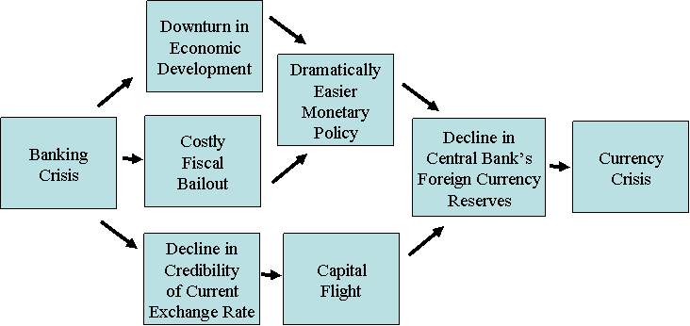
Source: Exchange Rate Determination

Leading Indicators of Currency Crises

- Excessive real appreciation of the emerging-market currency
- Weak domestic economic growth
- Rising unemployment
- A deteriorating current-account balance
- Excessive domestic credit expansion
- Banking-system difficulties
- Unsustainably large government budget deficits
- Overly expansionary monetary policies
- A high ratio of M2 money supply to reserves
- Foreign exchange reserve losses
- Falling asset prices
- A huge buildup in short-term liabilities by either the private or public sector

Remarks Before the Euro 50 Roundatable, Washington D.C., November 30, 2001. cited in Rosenberg, Michael R. (2003) Exchange Rate Determination, p. vi.
Yin-Wong Cheung, Menzie D. Chinn, and Ian W. Marsh (2000) “How do UK-Based Foreign Exchange Dealers Think Their Market Operates?” NBER Working aper 7524, cited in Rosenberg, Michael R. (2003) Exchange Rate Determination, Figure 1-3, p. 8.
Rosenberg, Michael R. (2003) Exchange Rate Determination, p. 28.
Evans, Martin D., and Richard K. Lyons (2002) “Order Flow and Exchange Rate Dynamics,” Journal of Political Economy, 102, 170-180.
Fan, Mintao and Richard K. Lyons (2003) “Customer Trades and Extreme Events in Foreign Exchange,” in Essays in Honor of Charles Goodhart, Paul Mizen (ed.), Edward Elgar: Notrhampton, MA, USA, pp. 160-179.
This concept is repeated in the next section.
Source: The Economist, “Food for thought,” May 27, 2004.
Multinational Finance, 10th edition
Multinational Finance, 10th edition
Remember, the nominal exchange rate is the actual spot rate while the real exchange rate is adjusted for inflation.
Note: with forwards no money changes hands until settlement.
Note: the reported current-account data does omit the contribution that U.S. foreign affiliates make to the aggregate sales by U.S. firms in international markets. For example, U.S. firms’ penetration of foreign markets exceeds the penetration of foreign firms in U.S. markets.
Rosenberg, Michael (2003) Exchange Rate Determination, p. 184.
Mishkin, Frederick (1996) “The Channels of Monetary Transmission: Lessons for Monetary Policy,” NBER Working Paper, No. 5464. cited in Rosenberg, Michael R. (2003) Exchange Rate Determination, Figure 9-11, p. 178.
Rosenberg, Michael (2003) Exchange Rate Determination, p. 205.
Rosenberg, Michael (2003) Exchange Rate Determination, p. 207.
According to the New Economy view, the surge in U.S. investment spending and the consequent rise in U.S. productivity help push U.S. growth significantly above the pace of overseas growth which strengthened the value of the dollar. The hype of the “New Economy” ended as the U.S. currency slid versus foreign currencies.
Rosenberg, Michael (2003) Exchange Rate Determination, p. 231.

