Fixed Income INVESTMENTS

“Fixed Income” investments (generally) make payments on a fixed schedule, bonds are the best known fixed income securities, but the term also includes mutual funds that invest in bonds, fixed income exchange traded funds (ETFs), CDs, money market funds, and fixed income annuities.

This note will focus on individual bonds (treasury, agency, municipal, corporate, high yield); bond mutual funds and ETFs (investment grade, municipal, high yield, multisector, international).

Exhibit 1: Major Credit Rating Companies
 | Moody's | S & P / Fitch
Investment Grade Ratings | Aaa  Aa  A  Baa | AAA  AA  A  BBB
Below Investment Grade  ("Junk Bond") | Ba  B  Caa  Ca  C | BB  B  CCC  CC  C
In Default |  | D

Note: Few companies are rated AAA. As of 2011 XOM, MSFT, JNJ and ADP all had AAA ratings.

Example: Calculating Bond Price
Consider a $1,000 face value bond maturing in 20 periods with coupon rate of 4.00% per period. The yield to maturity of the bond is 6.00% per period. The price of the bond is $770.60.

You can use the cash flow function on your financial calculator to solve for the price. CF0 = 0; CF1 = 40; F1=20; CF2 = 1000; CPT NPV; I/Y = 6; ↓; ENTER; CPT

If the bond's yield to maturity were to go to 6.01%, its price would become $769.64.

which represents a change of –0.12%.

The following table shows the change in the prices of bonds of various lengths as the bond's yield to maturity goes from 6.00% to 6.01%:

The table above confirms the intuition that the longer the bond's maturity, the greater the sensitivity of its price to interest rate changes.

Other things being the same, bonds with higher yield to maturity have a lower interest rate sensitivity. The following table shows the effect of the bond's yield to maturity.

Other things being the same, a higher coupon rate bond has a lower interest rate sensitivity. The following table shows the effect of coupon rate.

Duration Basics
Duration combines the bond's coupon rate, length (time to maturity), and yield to maturity to provide a single metric that measures the bond price's interest rate sensitivity.
- Duration of a zero-coupon bond is equal to its time to maturity.
- The higher the coupon rate, the lower the duration.
- For bonds priced at or above par, the longer the maturity, the higher the duration.
- The lower the yield to maturity, the higher the duration.

Macaulay’s Duration – the “effective maturity” the weighted average of the times to each coupon or principal payment.

Example: Calculating Duration
Calculate the duration of a 3 year 6% bond selling at par (annual payments).

(1) | (2) | (3) | (4) | (5)
Time until Payment (years) | Cash Flow | PV of CF  (Discount rate = 6%) | Weight | Column (1)  × Column (4)
1 | $60.00 | $56.60 | 0.0566 | 0.0566
2 | $60.00 | $53.40 | 0.0534 | 0.1068
3 | $1,060.00 | $890.00 | 0.8900 | 2.6700
Column Sums |  | $1,000.00 | 1.0000 | 2.8334

Modified Duration – a measure of the bond’s exposure to changes in interest rates.
Example: Duration of a Bond Portfolio

Bond 1: 7% annual coupon, 3 years to maturity, yield to maturity of 5%, price $1,054.46.
Bond 2: 6% annual coupon, 5 years to maturity, yield to maturity of 8%, price $920.15.
Consider a $100,000 portfolio that invests 60% of its money in bonds 1 and 40% in bond 2; this would work out to 59 units of bond 1 and 43.47 units of bond 2.

Step 1: solve for the portfolio yield:

Step 2: calculate portfolio duration

Convexity – the rate of change of the slope of the price-yield curve, expressed as a fraction of the bond price (the curvature of the price-yield curve).

Notes: Convexity is generally considered a desirable trait. Bonds with greater curvature gain more in price when yields fall than they lose when yields rise.

Interest rates, as depicted by the yield curve, are the primary drivers of bond prices. The following chart shows various shapes of the yield curve.

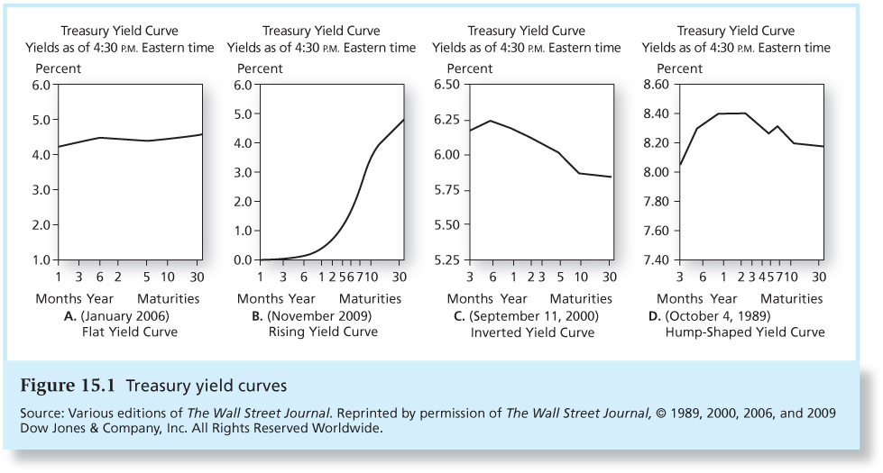

Basic Observations (Malkiel’s Bond Pricing Relationships)
- Bond prices and yields are inversely related.
- The price curve is convex; decreases in YTM have a bigger impact on price than increases in yields of equal magnitude.
- Long-term bond prices are more sensitive to interest rate changes.
- The sensitivity of bond prices to changes in yields increases at a decreasing rate as maturity increases.
- Interest rate risk is inversely related to the bond’s coupon rate; prices of low-coupon bonds are more sensitive to changes in interest rates than prices of high coupon bonds.
  - Higher coupon rate bonds have a higher % of value tied to coupons which means a lower “effective maturity”
- The sensitivity of a bond’s price to a change in its yield is inversely related to the YTM at which the bond is currently selling.

See https://www.fidelity.com/fixed-income-bonds for example
This example comes from http://myweb.whitman.syr.edu/rkshukla/Teaching/Investment_Analysis/Videos/ch16/Ch16.Summary.Notes.pdf
The relationship however is complicated by other bond characteristics.
Notice Rule #1 still holds, the longer the bond's maturity, the greater the sensitivity of its price to interest rate change.
This example comes from Running Money, by Scott Stewart, Chris Piros, and Jeff Heisler.
This example comes from http://myweb.whitman.syr.edu/rkshukla/Teaching/Investment_Analysis/Videos/ch16/Ch16.Summary.Notes.pdf
Note: The portfolio weights could be modified to achieve any duration between 2.81 (100% bond 1) and 4.44 years (100% bond 2).
Source: Bodie, Kane, and Marcus: Investments, 8th Edition, 2011.
Cited from Investments, 9th edition by Bodie, Kane & Marcus

