**Inflation**

**Inflation -** The rate at which the general level of prices for goods and services is rising, and, subsequently, purchasing power is falling. Central banks attempt to limit inflation in order to keep the excessive growth of prices to a minimum.[1] Inflation in the U.S. is measured by the change in the consumer price index (CPI) reported by the Bureau of Labor Statistics.[2]

**Consumer Price Index (CPI)** - tracks prices of a representative basket of more than 400 goods and services used by urban households, including: food, housing, consumer goods, gasoline, and clothing. The Federal Reserve Board targets 2% inflation.[3]

**Table 1: U.S. Historic Inflation Figures**

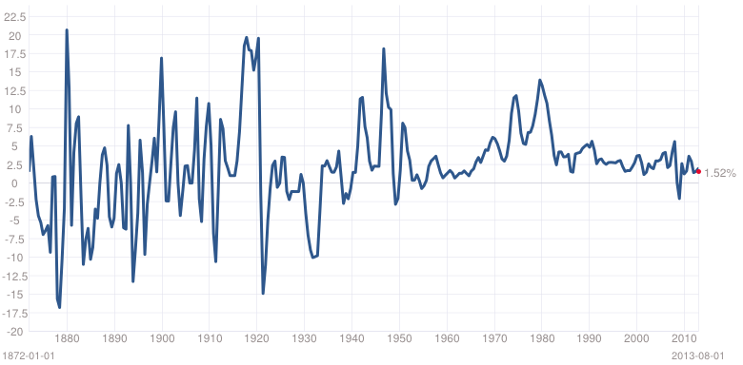

Source: http://www.multpl.com/inflation/

*Note*: For your standard of living to improve your income must rise at a faster rate than inflation.

Inflation impacts your investments as well. If the costs of goods rise at 4 percent, but your savings earn only 3 percent, then you are actually losing spending power!

**Nominal Interest Rate** – is the rate quoted in loan and deposit agreements. The equation that links nominal and real interest rates is:

(1 + R) = (1 + r) (1 + i)

where,

R = the nominal rate

r = the real interest rate

i = inflation

**Real Interest Rate** - is the percentage change in how much you can buy with your dollars – in other words, the percentage change in your buying power.

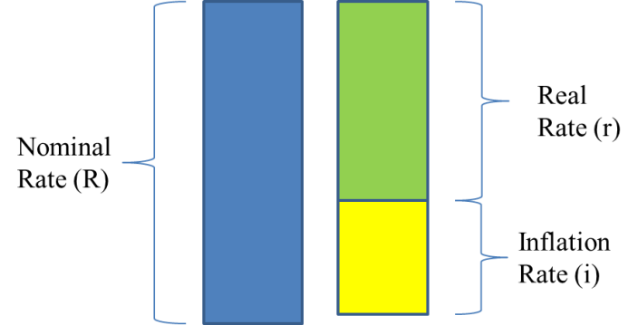

*Note*: Overcoming inflation requires either higher savings or higher return of return (ROR) on investment (or both). The equation for the real rate of return (rROR) is shown below:



where,

rROR = real rate of return

ROR = nominal rate of return

i = inflation

Example, inflation is 3 percent, the nominal rate of return on an investment is 6 percent. The real rate of return would be 2.91%.



*Note*: the formula above is consistent with the formula provided on the first page of this note.

(1 + nominal rate) = (1 + real rate) (1 + inflation)

1 + R = (1.0291)(1.03) = 1.06

*With present value calculations either discount nominal cash flows at the nominal rate or discount real cash flows at the real rate (as long as you are consistent you will get the same answer).*

*Graduate Assistants Kaoutar Houmairy and* Anunay *Swaroop, Babson College, contributed to the completion of this class note.*

1. http://www.investopedia.com/terms/i/inflation.asp
2. http://www.usinflationcalculator.com/inflation/current-inflation-rates/
3. http://www.stlouisfed.org/inflation-targeting/