**Asset Allocation**

*“…most investment professionals recognize that the asset allocation decision must take precedence over the choice of particular stocks.”[1]*

**Asset Allocation** - involves selecting different asset categories, such as stocks, bonds, and cash for a portfolio. There is no universal asset allocation; the asset allocation that works best for any given individual depends largely on the investor’s time horizon and ability to tolerate risk.

**Risk Tolerance** - the ability and willingness to lose some or all of the original investment in exchange for greater *potential* returns.[2]

**Time Horizon** - the expected number of months, years, or decades prior to a particular financial goal. An investor with a longer time horizon may feel more comfortable taking on a riskier, or more volatile, investments.[3]

Major asset categories: stocks, bonds, and cash.[4] Other asset categories: real estate, precious metals and other commodities, and private equity.

*“It is often said that stocks let us eat well and bonds let us sleep well,”[5]*

**Magic of Diversification** - spreading money among different investments may limit losses and reduce the fluctuations of investment returns without sacrificing too much potential gain.

**Firm-specific risk** – (unique risk; nonsystematic risk; diversifiable risk) can be protected against through diversification, it is tied directly to the performance of a particular security such as management style, R&D success, etc.

**Market Risk** – (systematic risk; non diversifiable) defines risk factors that affect all securities and are common to the whole economy such as business cycles, interest rates, energy prices, etc.

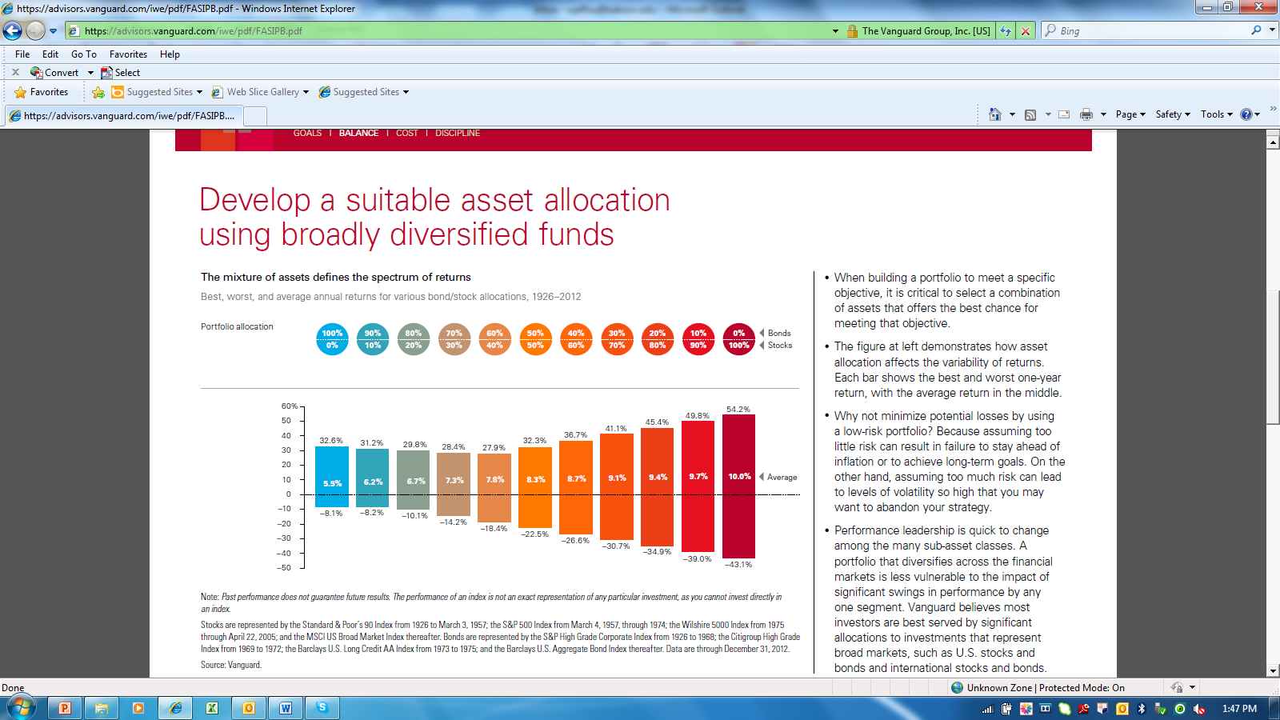

*Source*: https://advisors.vanguard.com/iwe/pdf/FASIPB.pdf

There is no consensus regarding the optional asset allocation, but many experts recommend higher weightings of stock for individuals with higher risk tolerance and longer horizons. Below are examples of recommended asset allocations.

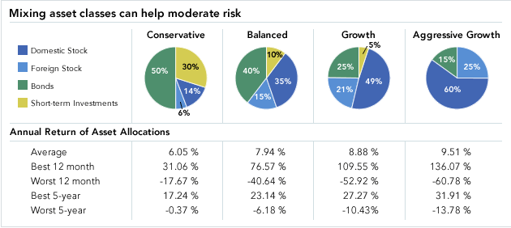

*Source*: https://guidance.fidelity.com/building-wealth/asset-allocation

With a *top-down approach* to building a portfolio, you first select target weights for various asset classes and then select securities within those asset classes. One way to achieve diversification is to select funds (with low expense ratios) that compliment your allocation goals.

*The following example is for informational purposes only and should not be considered investment advice.*

**Example Portfolio: Goal Retirement in 2050[6]**

|  |  |
| --- | --- |
| **Target Portfolio:**  U.S. Equity 55%  International Equity 35%  Fixed Income 5%  Commodities 5%  Cash 0% | **Actual Portfolio:** |

|  |  |  |  |  |
| --- | --- | --- | --- | --- |
| **Fund Name** | **Category** | **Ticker** | **Allocation** | **Exp.** |
| Vanguard Small Cap Index Inv | Small Blend | NAESX | 55% | 0.24% |
| Vanguard Total International Stock ETF[7] | Foreign Large Blend | VXUS | 34% | 0.16% |
| iShares Barclays Aggregate Bond[8] | Intermediate Term Bond | AGG | 5% | 0.08% |
| SPDR Barclays Capital Intl Treasury Bonds[9] | World Bond | BWX | 2% | 0.50% |
| iShares Gold Trust | Commodities Precious Metals | IAU | 4% | 0.25% |
| iShares Barclays TIPS Bond | Inflation-Protected Bond | TIP | 0% | 0.20% |

A fantastic source for information on thousands of mutual funds and hundreds of exchange traded funds (and even New York Stock Exchange, American Stock Exchange, and NASDAQ stocks) is the Morningstar database available through most university libraries.[10]

Once you’ve determined what general allocation you are looking for, you can screen for funds that meet your objectives. For example in the example portfolio above we select 55% U.S. equity. Under “Funds” you can select “Fund Category” then “U.S. Equity” there is an option to be more specific for example let’s select “Small Blend.” 698 funds meet this criteria, let’s now screen for fees. You can select “Expense Ratio” and then is less than 0.50. Now 40 funds meet our criteria, we could screen further for a minimum initial purchase of $3000 and we’ll have 26 funds to choose from, one of which is Vanguard Small Cap Index Inv (NAESX) which has a Morningstar rating of Gold and an expense ratio of 0.24.

*Note*: Morningstar covers both passive funds (e.g. index funds[11] and ETFs) and active funds (e.g. mutual funds).

**Active vs. Passive Management**

With the Vanguard Small Cap Index fund, the expense ratio is low, but “No passive small-cap index is perfect, as there are no financial health screens to prevent distressed firms from entering the mix.”[12] In addition, no one is hedging the currency exposure of my International Stock ETF (Symbol: VXUS). “During periods of high volatility in the global markets, the U.S. dollar tends to rise, which would weigh on the short-term returns of this fund.”[13] In general these inefficiencies may be insignificant, for example, “over the long term, currency volatility comprises only a small portion of the total risk of an international equity portfolio.” [14] So perhaps the benefits of low fees outweighs the costs that would be required to implement a more active strategy.

**Passive investment strategy** – Buying (and holding) a well-diversified portfolio without attempting to find mispriced securities.[15]

**Active investment strategy** – attempts to achieve returns higher than commensurate with risk by forecasting broad markets and/or by identifying mispriced securities.[16]

Primary arguments for active portfolio management:

* *Tax considerations* – high tax bracket investors may prefer tax-exempt municipal bonds and may tilt their portfolios to capital gains and investment opportunities where returns are sensitive to tax benefits.[17]
* *Investor profile* – (employment, age, wealth) a Toyota executive whose annual bonus is tied to Toyota’s profits should not invest additional money in auto stocks. Older investors may prefer “capital preservation” strategies.

*“There is a role for portfolio management even in an efficient market. Investors’ optimal positions will vary according to factors such as age, tax bracket, risk aversion, and employment…. [But] the risk adjusted performance of professional managers is mixed at best… [and] is broadly consistent with market efficiency.”[18]*

1. Source: Essentials of Investments, 9th edition by Zvi Bodie, Alex Kane, and Alan J. Marcus, Chapter 6 p. 50.
2. See “Expected Utility and Risk Aversion” available at: www.wendyjeffus.com
3. http://www.sec.gov/investor/pubs/assetallocation.htm
4. Cash and cash equivalents - such as savings deposits, certificates of deposit, treasury bills, money market deposit accounts, and money market funds.
5. Quoted from Taylor Larimore in “A Portfolio That's as Simple as One, Two, Three” *Wall Street Journal* July 7, 2013.
6. Based on Based on Morningstar Asset Allocation Indexes See morningstarvideo.edgesuite.net/player/moneysmart.html
7. Exchange Traded Funds (ETFs) are funds that track indexes like the NASDAQ-100 Index, S&P 500, Dow Jones, etc. ETFs don't try to outperform their corresponding index, but only replicate its performance. See: http://www.nasdaq.com/investing/etfs/what-are-ETFs.aspx#ixzz2hXacLubt
8. iShares are a family of exchange-traded funds (ETFs) managed by BlackRock.
9. SPDR funds are a family of exchange-traded funds (ETFs) traded in the United States.
10. Another great source is FINRA’s (Financial Industry Regulatory Authority) website: apps.finra.org/fundanalyzer/1/fa.aspx
11. An index fund is a mutual fund which holds shares in proportion to their representation in a market index such as the S&P 500.
12. Quoted from Morningstar Analyst Report NAESX dated Nov. 13, 2012 by Michael Rawson, CFA.
13. Quoted from Morningstar Analyst Report VXUS dated June 27, 2013 by Patricia Oey.
14. Quoted from Morningstar Analyst Report VXUS dated June 27, 2013 by Patricia Oey.
15. Source: Essentials of Investments, 9th edition by Zvi Bodie, Alex Kane, and Alan J. Marcus, Chapter 8 p. 241.
16. Source: Essentials of Investments, 9th edition by Zvi Bodie, Alex Kane, and Alan J. Marcus, Chapter 18 p. 597.
17. The current capital gains tax rate is 15% (2012) while the highest ordinary income tax rate is 35%. See http://taxes.about.com/od/Federal-Income-Taxes/qt/Tax-Rates-For-The-2012-Tax-Year.htm for additional detail including Married filing separately, and head of household.
18. Source: Essentials of Investments, 9th edition by Zvi Bodie, Alex Kane, and Alan J. Marcus, Chapter 8 p. 242 & p. 257.